Scorpions

Log onto: http://kids.nationalgeographic.com/kids/animals/creaturefeature/scorpions/
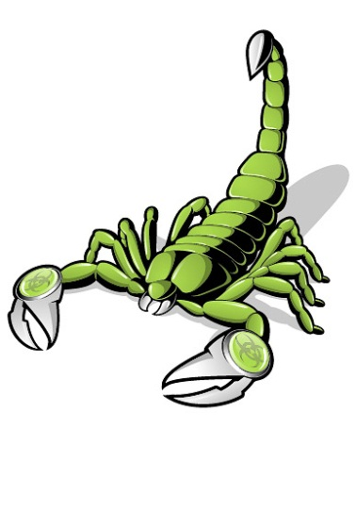
- What are scorpions?
- How many legs do they have?
- How do they grab an insect?
- What do they use their poison for?
- What simile is used on page 2?
- How long have scorpions been around for?
- Where do they live?
- How many scorpions have enough to kill a person?
- What do scorpions eat?
- What did researchers do with scorpions?
- What do scorpions have a difficult time living without?
- True or false: Scorpions are nocturnal.

