Nile Crocodiles
Log onto: http://kids.nationalgeographic.com/kids/animals/creaturefeature/nile-crocodile/
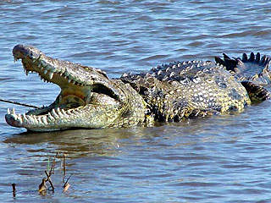
- How long do young crocs live under their mothers’ protection for?
- What do the young crocs feed on?
- How does a male crocodile get a female’s crocodile attention?
- Describe a suitable nest for a crocodile to lay her eggs in.
- Why would a female crocodile leave her nest for while she is watching her eggs?
- How does the female crocodile help her eggs hatch?

True or False:
- Crocodiles are cold-blooded.
- Crocs have been around for more than 200 million years.
- An adult male crocodile can grow as long as 40 feet.
- They have been known to live up to 80 years.

Fill in the blank words:
- Nile crocodiles live primarily around the _________, _________ and __________ of southern Africa.
- Nile crocodiles will eat ___________ ______________!
- A ____________ Nile __________ may often cool off by keeping its mouth open.
- For years Nile crocodiles were hunted for their ________, which were made into ___________, purses, ___________ and other leather goods.

